

**Submitted by:** **Submitted to:**

**NAME: Rahul Gusain Omkarendra Tiwari ROLL NO.: R214220900**  
**BATCH: 1 DevOps**

# **CI - CD Lab**

**Jenkins and Github Actions**

CLI Commands:

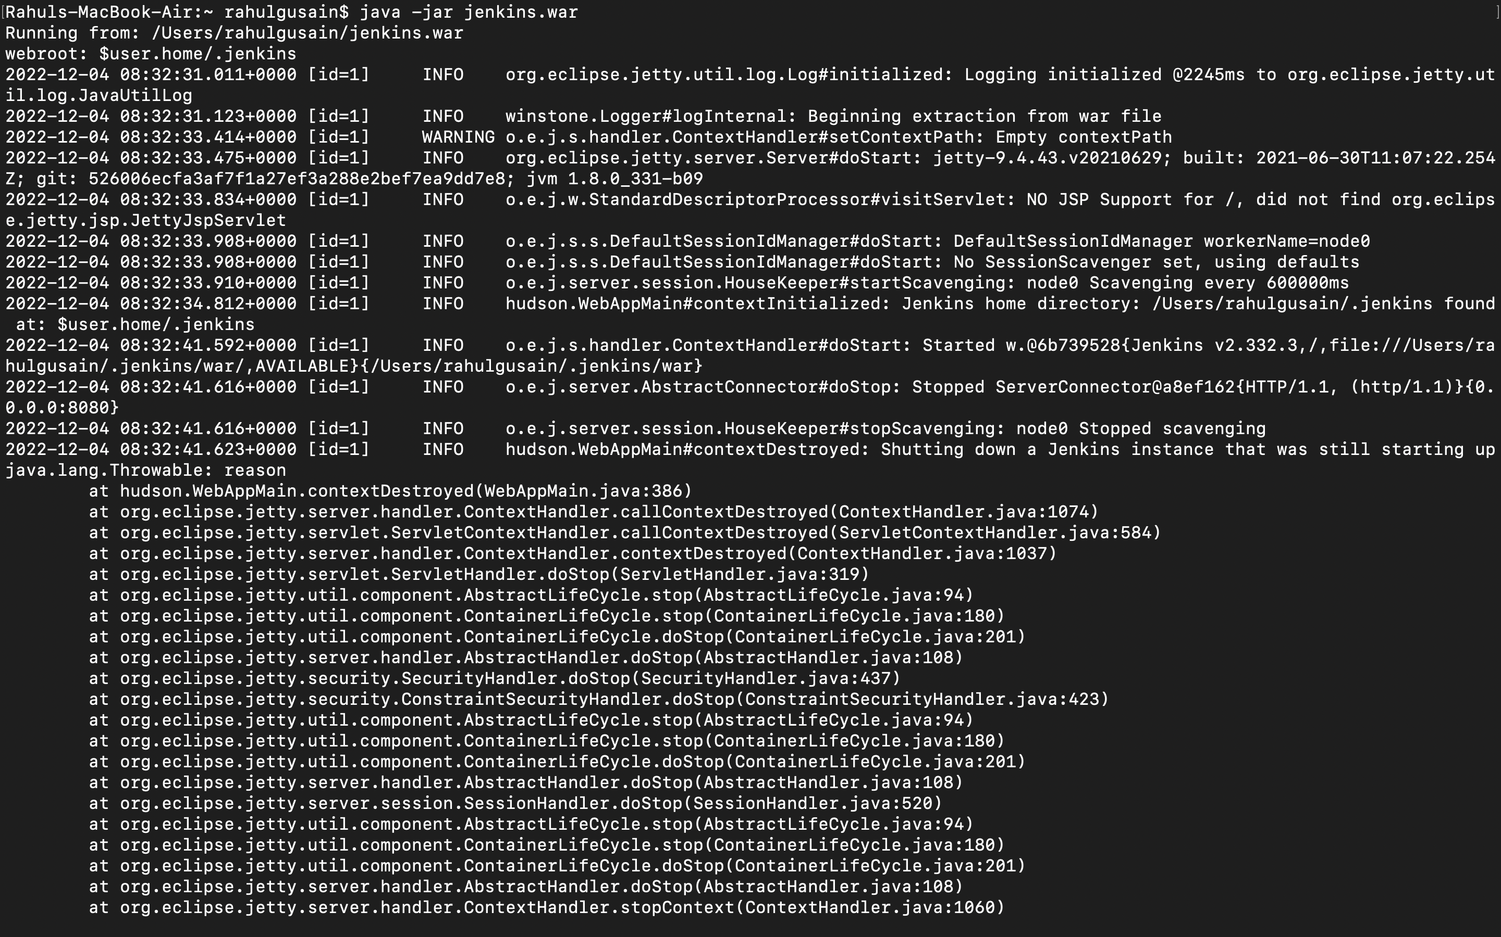

Jenkins Terminal:

